*Educating a New* Burkina Faso

*Generation of leadears* The party of Death ,

We will defead   
*Burkina Institut of Technologie* Koudougou, le 26/05/2025

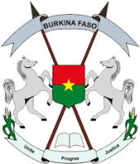

**TEACHER** : Dr ZONGO

**MODULA** : Financial Management

**THEME** :Choose your company ,present it, do a

market study , a feasibility study , a technical study , present your openning report and assess the

different marke

***MEMBERS OF GROUPE***

|  |  |  |
| --- | --- | --- |
| **Numer** | **Name** | **First Name** |
| **01** | **OUEDRAOGO** | **R-W Corneille** |
| **02** | **KIEMTORE** | **Adonis Simplice** |
| **03** | **KIENDREBEOGO** | **Arnaud** |